Spanish Geo-Economics:
Past, Present, and Future

The economy of Spain is marked by two geographic contrasts. First is its location—it is peripheral but also central. It is peripheral in Europe: Berlin and Vienna are both closer to Moscow or Istanbul than to Madrid; Rome and London are closer to Berlin or Vienna than to Madrid. Yet Spain is also central, within the world economy. It straddles the Strait of Gibraltar, and is located in the middle of the enormous Atlantic watershed in which nearly two-thirds of global GDP is generated.

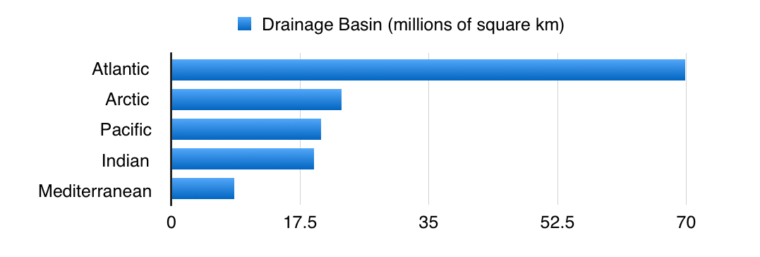
Spain has ties not only to Europe, but also to Africa (via Ceuta, Melilla, and the Canary Islands), the Americas (via the Spanish language), and South Asia (via the Mediterranean). The Atlantic, moreover, is 2-4 times narrower from east to west than is the Pacific Ocean in most areas, so trans-Atlantic shipping is relatively cheap.

The second geographic contrast is Spain’s size. It is large in terms of the total amount of land it comprises; larger than any other country in the European Union apart from France. However, Spain is not so large in terms of non-mountainous land, and is actually quite small in terms of the amount of flat coastal land it possesses. Most of what little flat coastal land Spain does own is located in either Catalonia or Andalusia, regions that are on opposite sides of the country from one another. Catalonia is adjacent to France and faces the Mediterranean; Andalusia next to Portugal and the Atlantic. Today they account for one-third of Spain’s GDP, yet also give Madrid a lot of grief: Catalonia with its calls for increased autonomy or full independence, Andalusia with an unemployment rate that is higher than that of Greece.

These two geographic contrasts begat a third, historical contrast: that of Spain’s brief, bi-religious golden age. First, in the great Islamic era in Spain, the country’s peripheral position within Europe became less significant, as Spain gained access to the trade routes of Asia and Africa via Islamic and Arabic communities. At the same time, Spain’s lack of flat land relative to other European countries also became less significant, because in comparison to other areas of the Arab and Islamic worlds, in which Spain was then a part, the Spanish had a large amount of arable and flat land to develop.

Immediately following the expulsion of Islam from Spain in 1492, when the inhabitants of Spain lost access to Islamic trade and investment, Spain’s golden Age of Discovery began. Both the Spanish and the Portuguese founded their own Atlantic trade routes to Asia and the Americas. Yet even this feat gave Spain only a brief surge of significance. Spain was soon eclipsed by other Atlantic countries with more flat land, notably France, or with more flat coastal land, notably England.

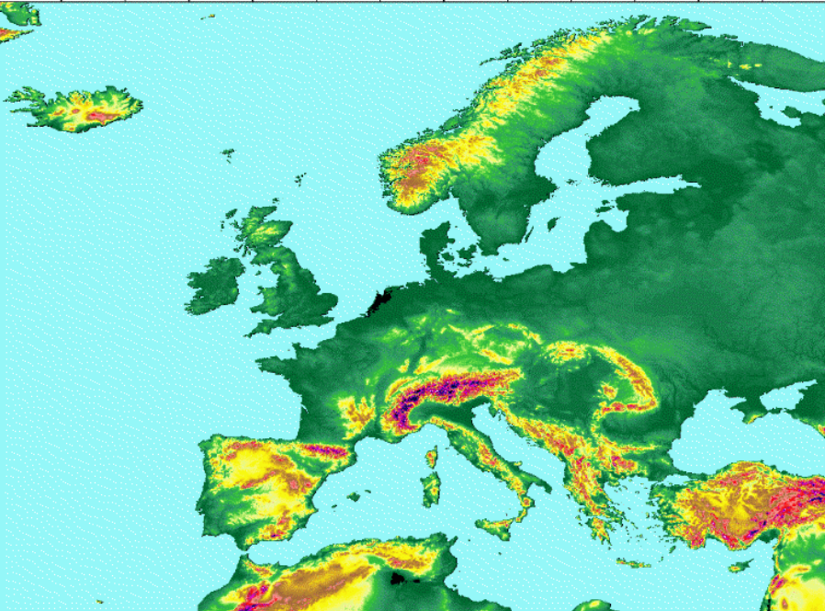
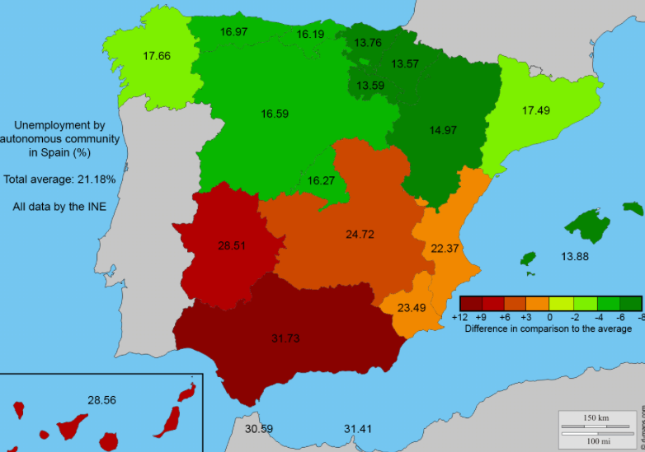
Several centuries later, when the construction of railways helped to open up the vast continental flatlands of Eastern Europe to economic development, Spain’s position within Europe became even more peripheral. Continental Europe’s centre shifted from Paris towards Berlin; today the Spanish GDP is 2.8 times smaller than Germany’s. If Catalonia were to secede, Spain’s GDP would no longer even be double the size of small but central economies like the Netherlands, Sweden, Switzerland, or Poland. The GDP of all of Iberia - Spain plus Portugal - is now 30 percent smaller than that of Italy.

In the past decade, Germany alone has accounted for close to 60 percent of the Eurozone’s GDP growth, whereas peripheral or mountainous economies like Spain, Portugal, Cyprus, Greece, Ireland, and Finland have either stagnated or shrunk. Even within struggling European countries there is a pronounced divide between core and peripheral areas. In Italy, flat northern regions like Lombardy and Veneto have 7-8 percent unemployment, yet rugged southern regions like Calabria and Sicily are at 21-23 percent. The mountainous Mediterranean region of France is thought to have 11.6 percent unemployment, compared to under 10 percent for the rest of France. And in Spain, which is the EU member-state with the greatest regional disparities in employment, northern Basque Country, Aragon, and Navarra have official unemployment rates of 13-15 percent, while southern Ceuta, Melilla, Extramadura, and Andalusia suffer between 28-31 percent.

It has therefore surprised many to see Spain’s economy bounce back, to a certain extent, during the past two years or so. In 2016 Spain’s GDP grew by an estimated 3.05 percent, compared to 0.75-1.85 percent in the four other major economies in the EU: Germany, Italy, France, and Britain. If you leave out Brexit-ing Britain and juggernaut Germany, Spain in 2016 accounted for one-fifth of the entire EU’s GDP growth. Spain would count for an even larger share of the GDP growth of the Eurozone, given that most of the fastest-growing EU economies this past year have been countries that do not use the Euro, notably Romania, Sweden, and Poland. Spain’s growth is also no longer lagging behind Europe’s most significant non-EU economies. Norway, Switzerland, and Turkey grew at just 0.8,1.0, and 3.3 percent, respectively, while Russia’s is thought to have shrunk by 0.76 percent. This is quite different from the years 2010-2014, when Russia was growing at 3.4 percent per annum, Turkey at 6.1 percent, Switzerland 2.0 and Norway 1.4—while Spain’s was contracting at a rate of 1.3 percent. Most forecasts predict that Spain’s rebound will continue in 2017.

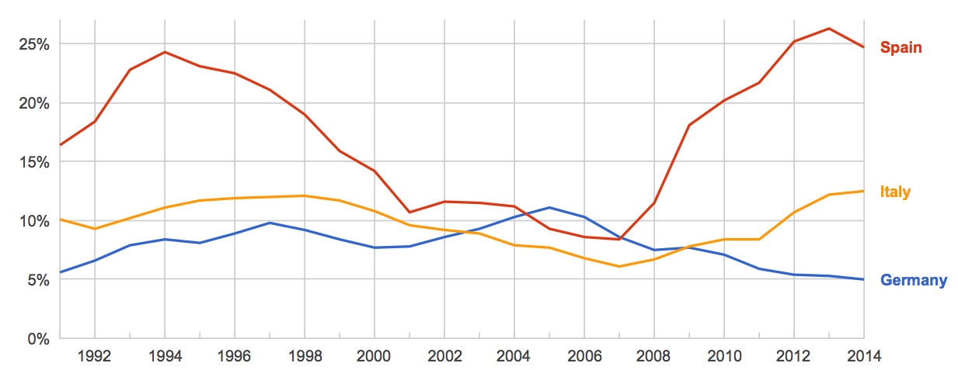
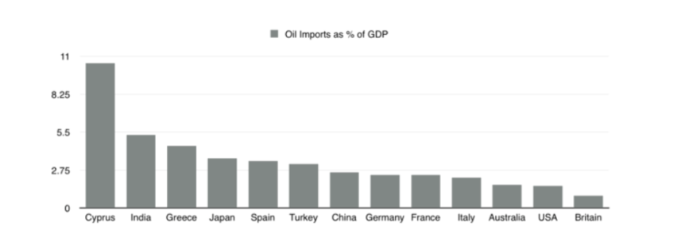
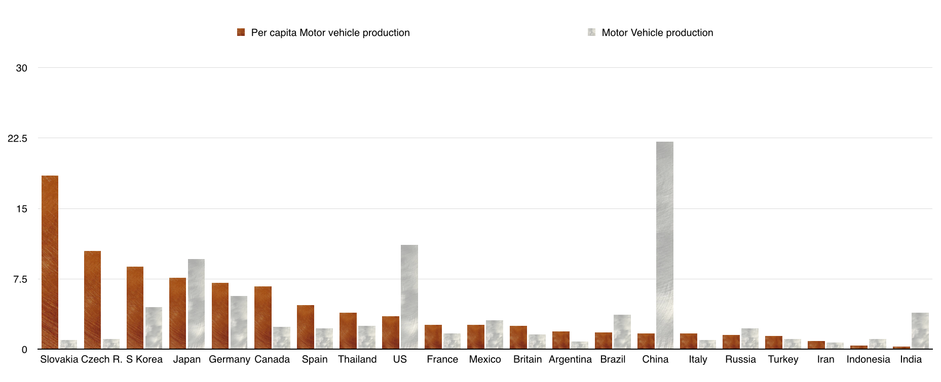
Spain’s three percent growth is especially notable in comparison to Italy, which grew its GDP by just 0.75 percent in 2016. While both countries have been suffering since 2008, Italy has been stuck in something like a great recession, whereas Spain has been in a Depression. This is in keeping with geoeconomic trends: Italy has a central location within Europe, and possesses more coastal flatland than the rest of Mediterranean Europe (not counting northern France) put together. The disparity between Italy and Spain also reflects the political fact that Europe cannot afford to have Spain and Italy be in depression simultaneously, as they account for approximately 18 percent of the GDP of the EU and 27 percent of the GDP of the Eurozone. Thus it might not be wholly coincidental that, just as Spain’s economy is finally growing well again, Italy might be reaching what could prove to be its worst moment, with banking troubles and the 5-R’s (Renzi’s Recent Reform Referendum Rejection) that may lead to 5-Star’s (if anti-Euro parties gain in Italy’s 2017 election).
Unemployment Rate

Spain is also benefiting from the crash in oil prices more than Italy is. Spain is Europe’s third largest oil importer and second largest exporter of cars, which benefit from cheap oil. Italy by contrast is the Eurozone’s top oil producer; Italy produces more oil than Spain, France, Greece, and Turkey combined, which is slightly more than Germany does. Spain meanwhile is also the largest LNG importer in the Eurozone, taking in more the next largest, France and Italy, combined. Spain’s neighbours - specifically Portugal, but also fellow Mediterranean states like Italy, Greece, Turkey, and Morocco - need cheap energy too: Southern Europe depends a lot more on imports of oil and gas than does Northern Europe.
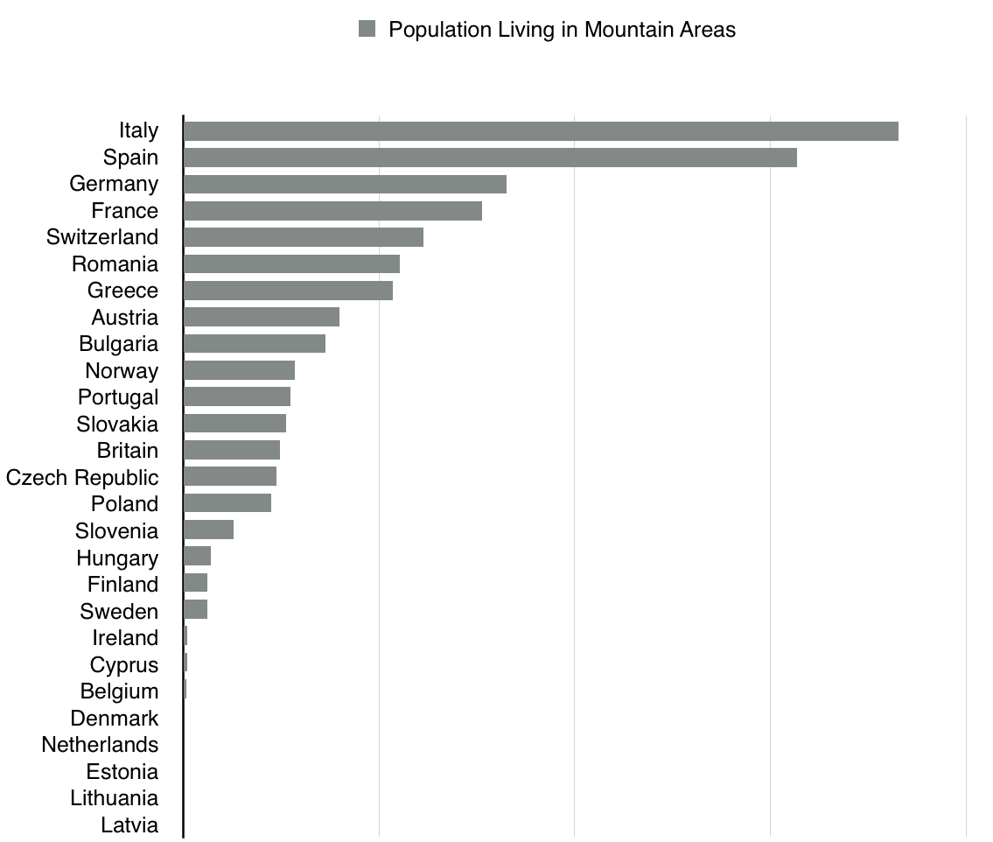
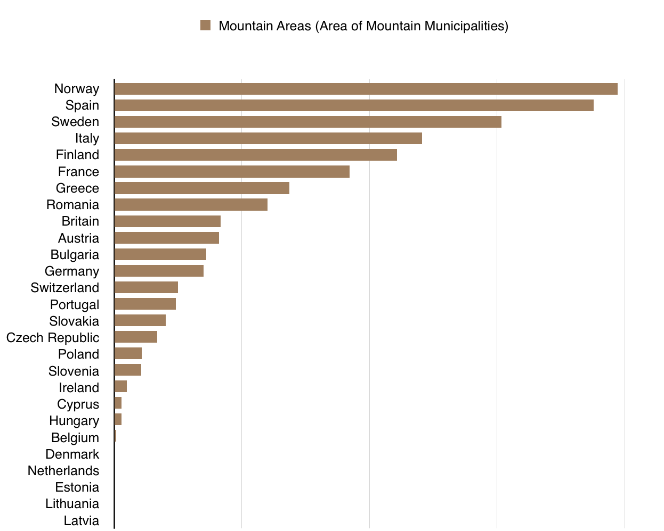
There are several conditions that Spain, and the Mediterranean region in general, will require if its economic growth is to continue going forward. Foremost among these is global growth and global trade. Spain, Portugal, Italy, and France will need to be able to interact with speakers of Romance languages in the Americas and in Africa, and will also need American, African, and South Asian countries to grow their economies so that greater commercial opportunities can be presented by way of the Atlantic, Mediterranean, or cyberspace. There is some reason for optimism here. Populous African and South Asian countries, namely India, Pakistan, Bangladesh, Myanmar, Ethiopia, Tanzania, and Kenya, have been growing rapidly in recent years. India in 2016 is thought to have had the fastest GDP growth of any country in the world apart from Myanmar, Iraq, or Ivory Coast. Investment in Morocco, a country of 33 million people crucial to Spain, has been growing at a decent pace. So too has the GDP of the Americas, due to the recovery of the huge US economy.

The major Spanish-speaking South American markets, Colombia, Argentina, and Peru, look stable as well, in spite of being hurt by low commodity prices. At the same time, the wealth of the enormous Spanish-speaking population of the United States continues to grow; young and bilingual second- and third-generation Hispanic-Americans are coming of age every year and are in many cases joining America’s professional class. Meanwhile, technology seems finally to be approaching the point whereby, for speakers of the same language, high-skill workers will often be able to work remotely from abroad in a relatively seamless fashion. People in general might soon also be able to spend a lot more time outside their home countries without losing contact with the coworkers, families, or friends they have left behind them, as new generations of webcam technologies—or even virtual reality—improve communications. All this bodes well for Spain.

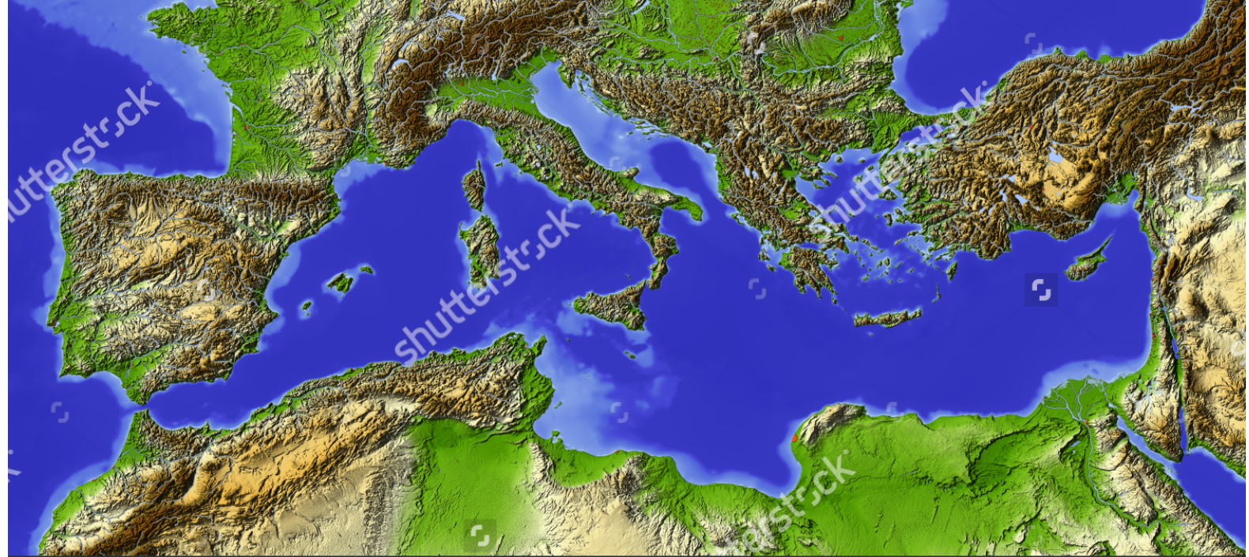
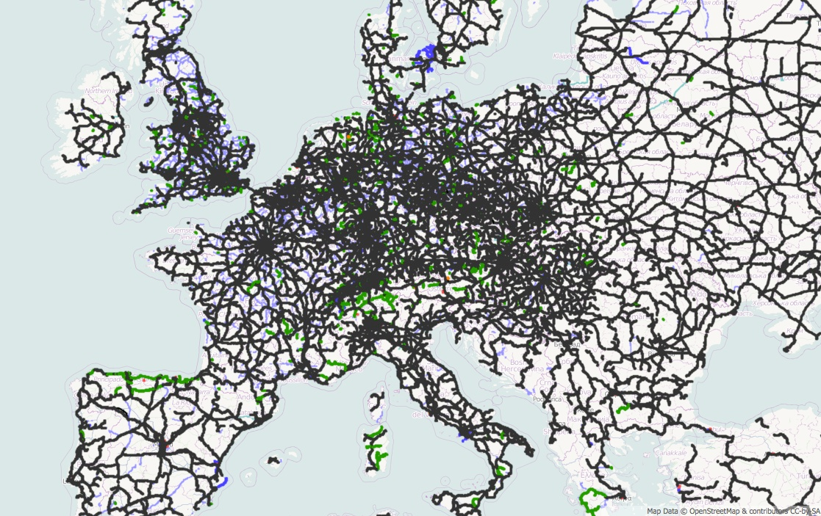
Spain cannot, however, rely too much on global growth to spur its own. It, and the other Mediterranean countries, will need to boost their own domestic economic heft as well. More than anything else, this will mean finding some way to overcome the mountainous terrain which has thus far limited their development. Together, Spain, Italy, Turkey, Greece, Morocco, Algeria, the Balkans, and the Levant have over 100 million people living in mountain areas. Ethiopia, Yemen, and Iran have an additional 70 million. And the Spanish-speaking countries of Latin America have a higher share of their populations living within mountain areas than do any other regions in the world. [Indeed, the highest-elevation cities in the world to have at least a million residents are La Paz-El Alto (3800 metres), Quito (2850 metres), and Bogota (2600 metres). The highest elevation cities with at least four million residents are Bogota (8 million residents) and Mexico City (9 million). The world’s ten highest-elevation cities with at least half a million residents are in Latin America, Africa, or South Asia]. More importantly, of the largest cities within Europe, several of the highest elevation ones are in Spain. Madrid, the EU’s third largest city, has the highest elevation of any capital city in Europe by a wide margin.
Mountain Railway in Majorca, Spain

The question is: to what extent can technology “move mountains”? The main challenge with mountains is one of high fixed and variable transportation costs. It is very expensive to build, maintain, and use infrastructure like railways and highways within mountainous areas. Trains and long trucks in particular cannot handle sharp inclines, sharp turns, or pass through low or narrow tunnels or overhangs easily. As a result, mountain areas tend to have high labour, capital, and fuel costs when transporting bulk goods like food, fuel, or other necessities of modern economic and industrial life. Maintenance and insurance costs also tend to be high, given dangers and inconveniences arising from common conditions like ice, snow, fog, landslides, avalanches, rockfalls, or sheer drops off narrow, winding, hairpin-turning roads. Even aircraft face challenges in mountain areas, particularly due to their dearth of long flat runways needed to allow large heavy planes to take off, but also because mountain areas have more difficult and erratic weather and wind and, historically, the risk of crashing into mountainsides. These are just a few of the challenges new technologies will need to surmount. In a future MacroGeo report, we will discuss whether they are likely to be capable of doing so any time soon.
European Railway Map

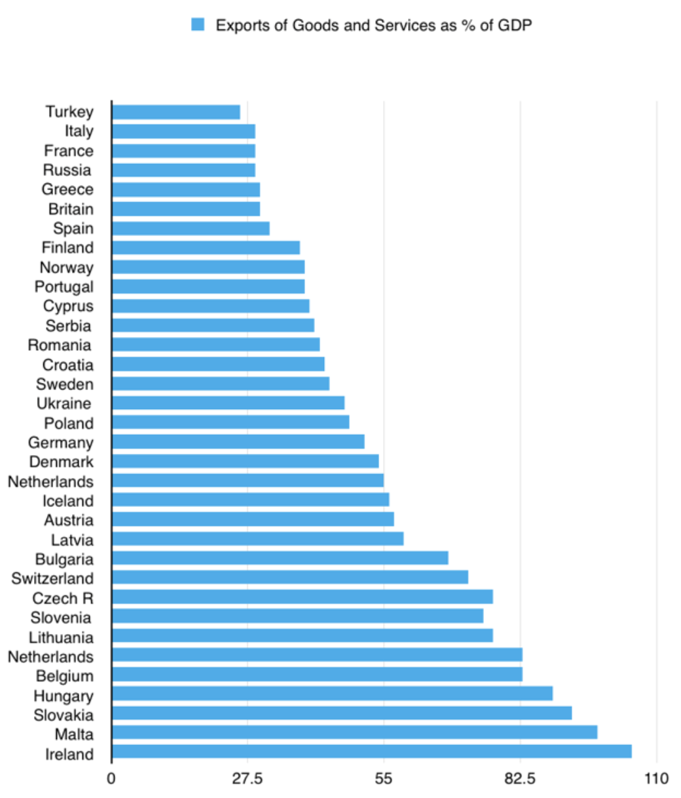
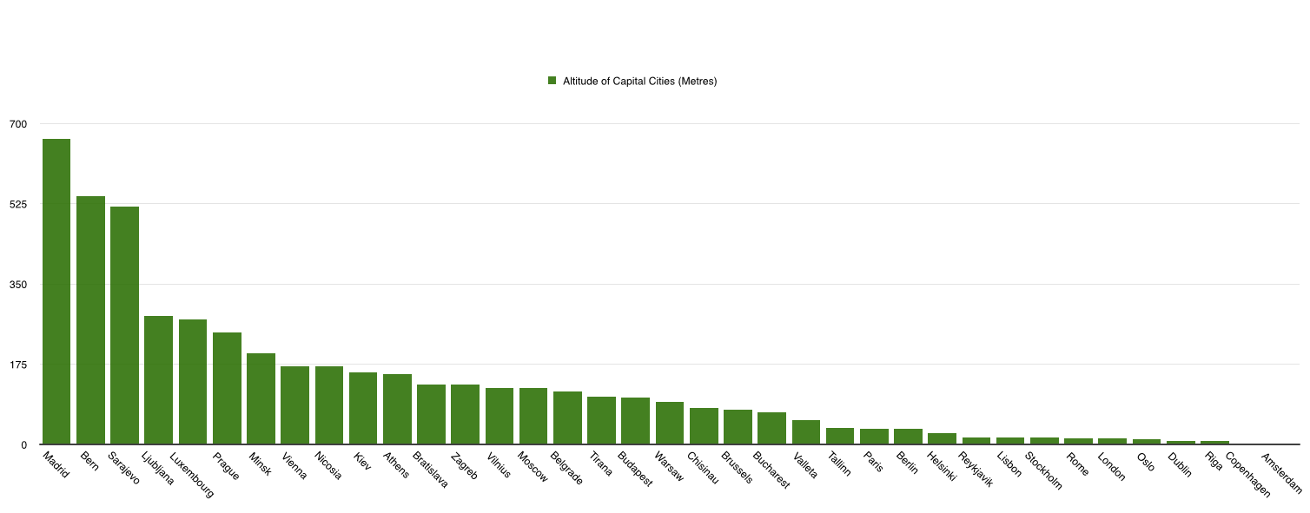
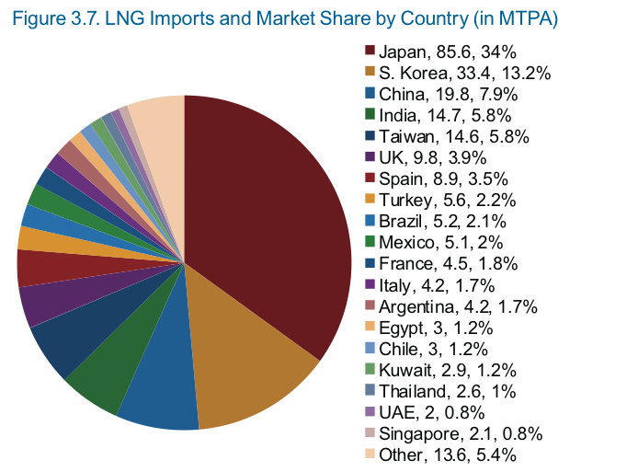
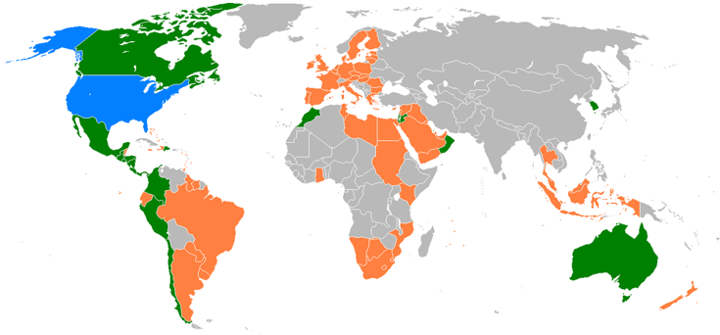
Another question is how the recent political shift in the United States could impact Spain. With Trump in the White House and Republicans now controlling both houses of Congress—albeit with only a narrow majority in the Senate—it seems plausible that America’s trade deficit will decrease, as a result of the Republican intention to lower taxes and environmental regulations as well as Trump’s plan to raise infrastructure spending and spur American industry at any cost. This could have two major outcomes for the world economy. First is to hurt export-dependent economies which rely, either directly or indirectly, on American consumers to purchase their products. Second is to keep energy prices, and in particular gas prices, low, by continuing the American shale energy boom that has taken place during the past decade. Spain, luckily, is not an export-dependent economy, and is actually a significant importer of energy. Countries with links to Spain, meanwhile, notably Morocco but also most Pacific economies within Latin America, are among the few in the world to possess bilateral trade deals with the United States—a boon, given Trump may not sign any new ones.

Green = Countries that have trade deals
with the US that are already in place
Orange = Proposed trade deals with the
US that may not be passed anytime soon
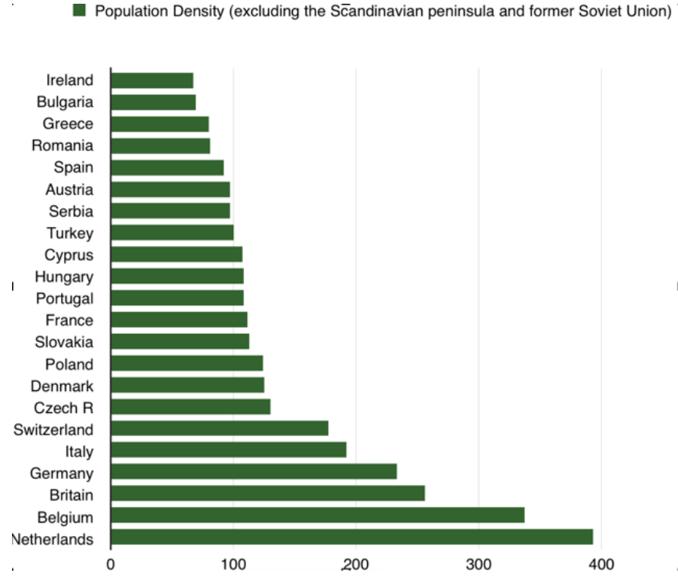
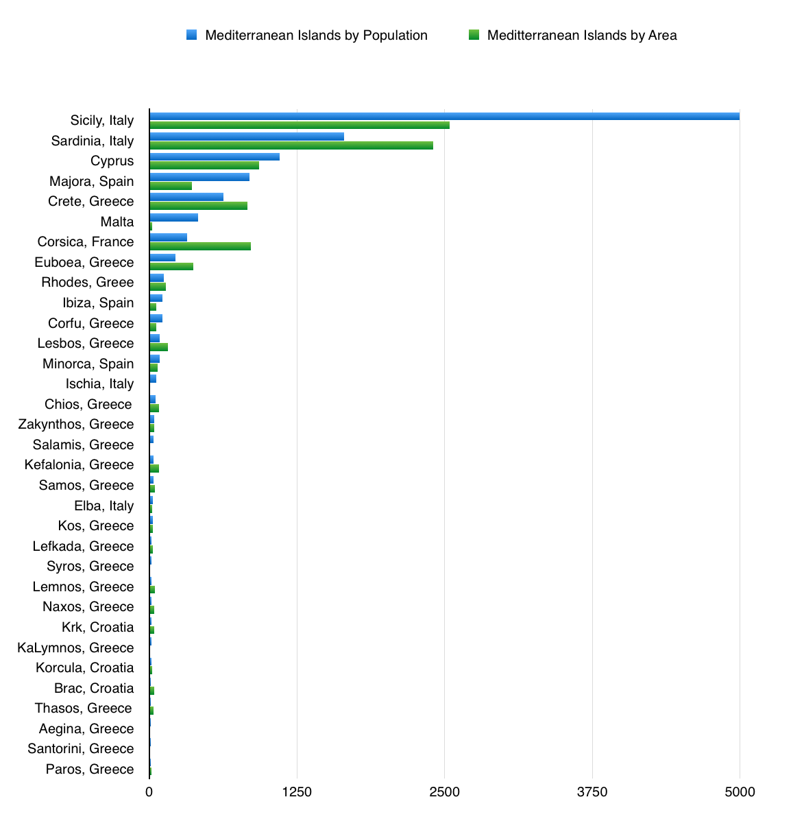
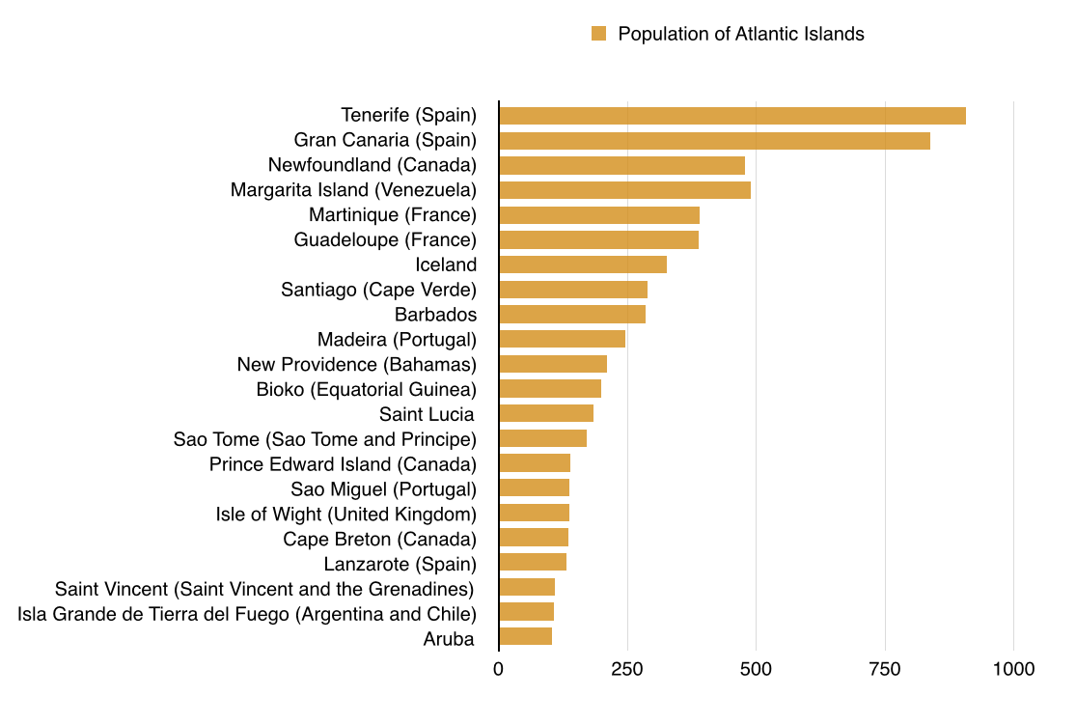
We have discussed already how Spain posseses a relatively large amount of land, compared to other European states. Outside of Scandinavia or the former Soviet Union, the only European countries with more land per capita than Spain are Ireland, Bulgaria, Greece, and Romania. Spain’s ability to capitalize on this land depends not only on its ability to overcome mountainous terrain, but also on the general value of land. In other words, it depends on industries such as agriculture, tourism, and solar and wind farms. Where tourism is concerned, Spain is already a major player in Europe, thanks in part to its long, warm coastline and its islands in the Atlantic and Mediterranean. Spain may benefit from the aging Baby Boomers of northern Europe (including Russia), who may cause an increase in “snowbird” tourism or even health tourism.
Does not include Atlantic islands with more than a million inhabitants, namely Britain, Hispaniola, Cuba, Ireland, Long Island, Manhattan Island, Puerto Rico, Trinidad, or Sao Luis
Spain has few Mediterranean islands of note, compared to Italy or Greece. Majorca, Ibiza, and Minorca have 1.1 million inhabitants in total; Spain’s Canary Islands in the Atlantic have 2.1 million.

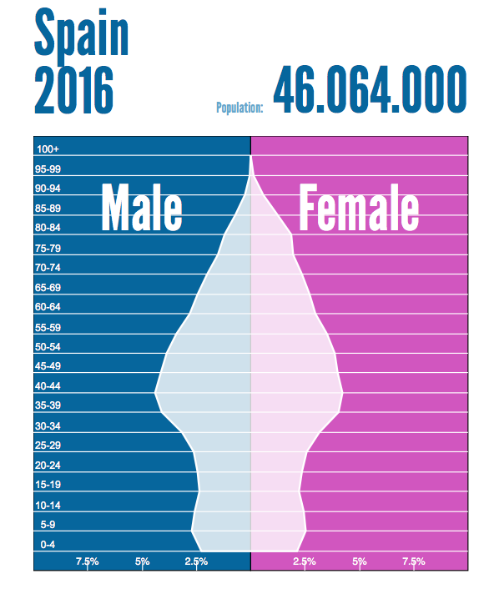
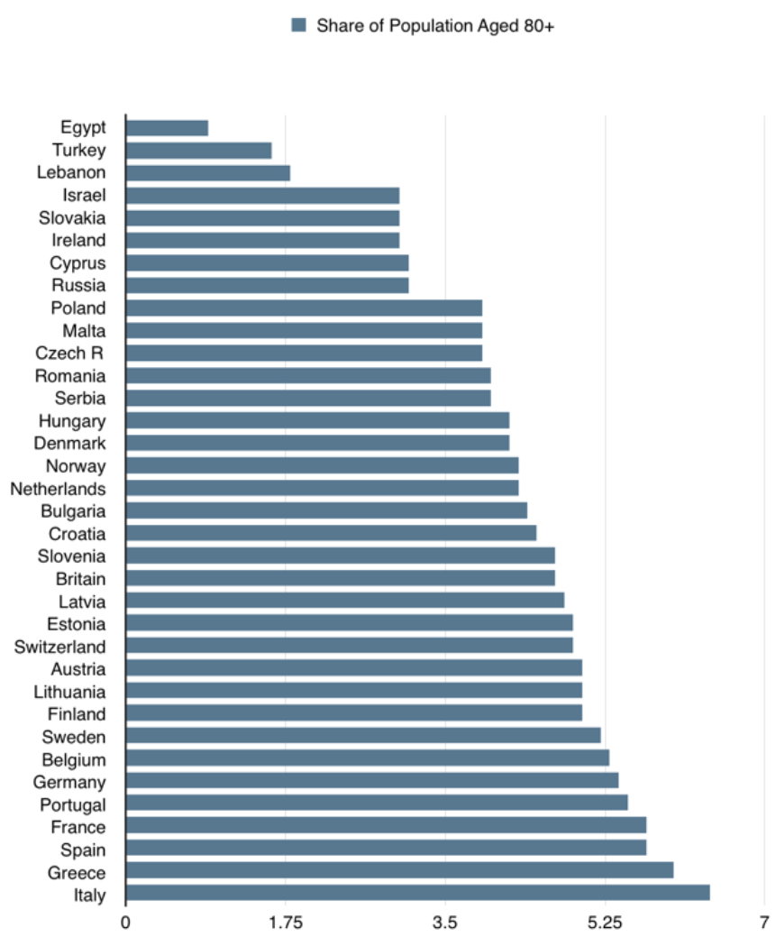
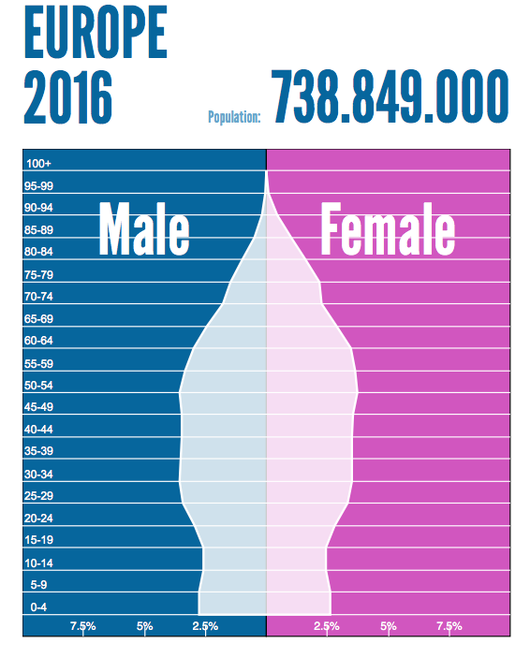
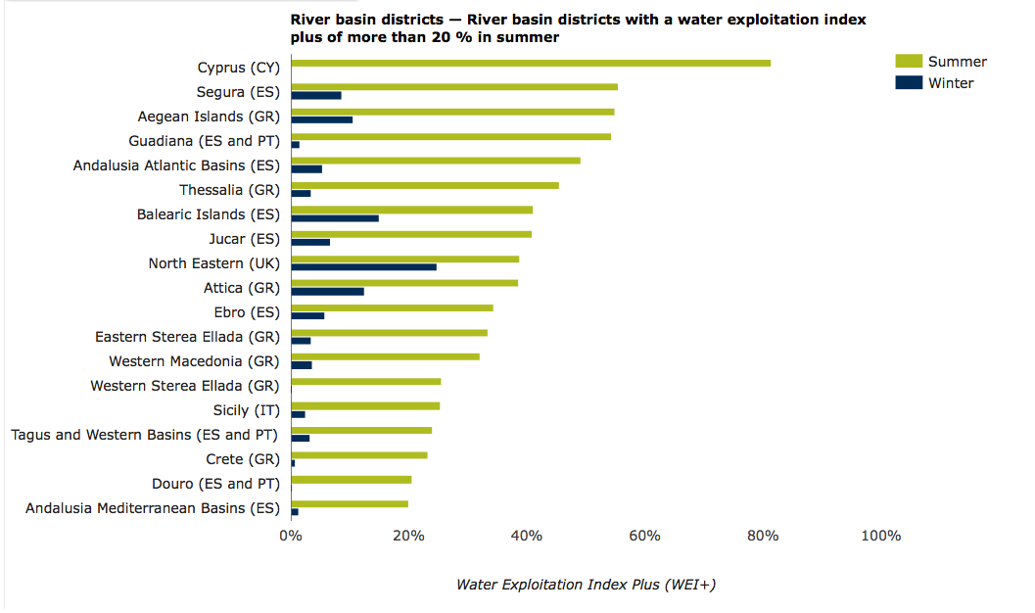
In renewable energies too, Spain and its neighbours are significant. Portugal gets more of its energy from renewables than does any European country apart from Sweden or Denmark. Morocco opened the world’s largest solar farm in 2016. And the large economies of Spain and France get more than two-thirds of their energy from non-fossil fuel sources. Spain is third in the world in solar power production, fourth in wind power production, and twelfth in nuclear power.

The risks to Spain are fourfold. One is the issue of freshwater supply and distribution, as shown in the graphs above. Another is the large, growing elderly population of Spain, and of Mediterranean Europe in general. (Though if you add Turkey, Israel, and the Arab world, then the Mediterranean is far younger than northern Europe or the former Soviet Union).

A third risk is of divisions within Iberia: that Iberia’s central area, in and around Madrid, will have its relationship with the Iberian periphery—Portugal, Catalonia, Andalusia, Basque Country, etc.—weaken. This cannot be ruled out, but, on the bright side, it seems likely instead that the current fragmentation within the EU will serve rather to increase the internal cohesion of Iberia, or at least that of Spain, by making areas like Catalonia less likely to balance Brussels and Madrid off of one another. While it is true that a Scottish departure from Britain might embolden Spain’s secessionist movements, it is far from clear that Scotland would actually attempt to leave Britain in any serious fashion, given that Scotland is outnumbered ten to one by the English. The geopolitical outlines of Britain and Spain are also dissimilar: in Britain the combination of Scotland, Wales, and Northern Ireland has just 10 million people, more than half of whom live in Scotland, whereas in Spain no single region predominates, and together Spain’s periphery heavily outnumbers its centre.

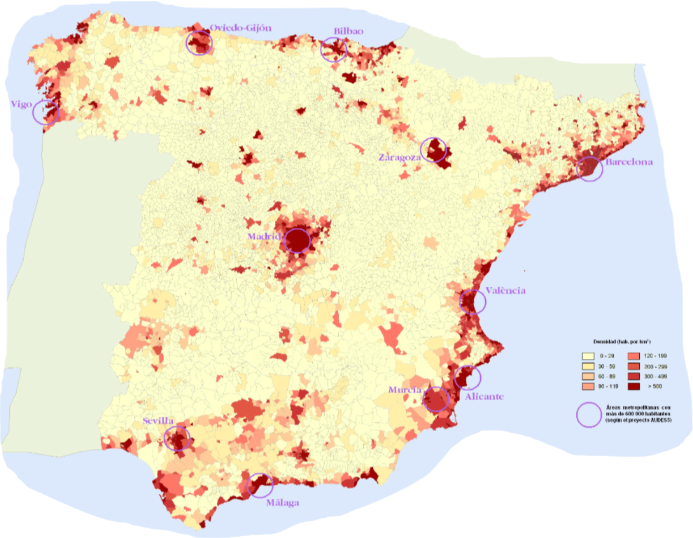
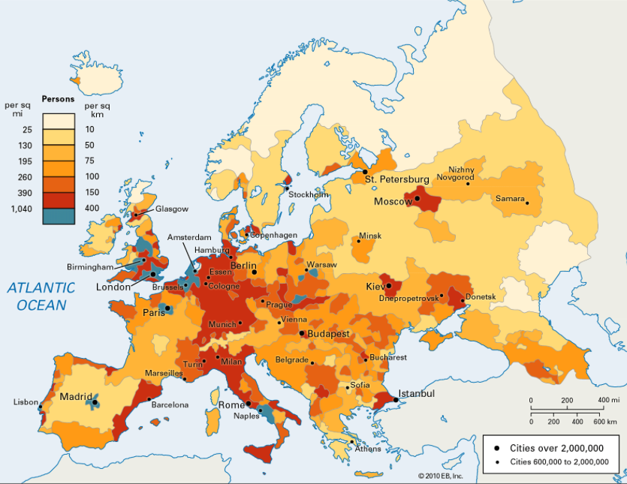
There is, finally, a European risk. This is that EU or Eurozone members will decide they have no choice but to sacrifice Spain’s recovery in order to keep Europe’s other constituent nations pliant; in other words, that Spain would become the next Greece. Spain would obviously rather stay out of such politics; but it has been unable in the past to do so. Spain has historically been too weak or divided to avoid being a regional battleground. The Spanish Civil War between Fascism and Communism, the Napoleonic Wars between England and France, an 800 year struggle between Islam and Christendom, even the Punic Wars between Rome and Carthage—all these were decided, to a substantial degree, by battles within the territory of what is today Spain. If, however, Spain can capitalize on its size and strategic location, and no longer be held back by its rugged landscape and position on the outskirts of Europe, it might gain the will and the wealth to decide upon its own political course. (Ideally, it would choose to remain a part of European institutions, instead of launching a Spexit). This is by no means certain but, were it to occur, Spain may finally enter a new golden era.

Sources:

The CIA World Factbook
The World Bank
The International Monetary Fund
Future Economics
Wall Street Journal, “Oil Price Winners and Losers Around the Globe”
Nordic Centre For Spatial Development, “Mountain Areas in Europe”
The Guardian, “Total Forest Coverage By Country”
European Environmental Agency, Water Exploitation Index
Towards a GIS-based Analysis of Mountain Environments and Populations
United States Geological Survey
World Resources Institute
OICA, “World Motor Vehicle Production By Country and Type”
International Gas Union, “2016 World LNG Report”
Populationpyramid.net (base data from the United Nations)

